***Brief Research on chatbots for Financial Inclusion***

[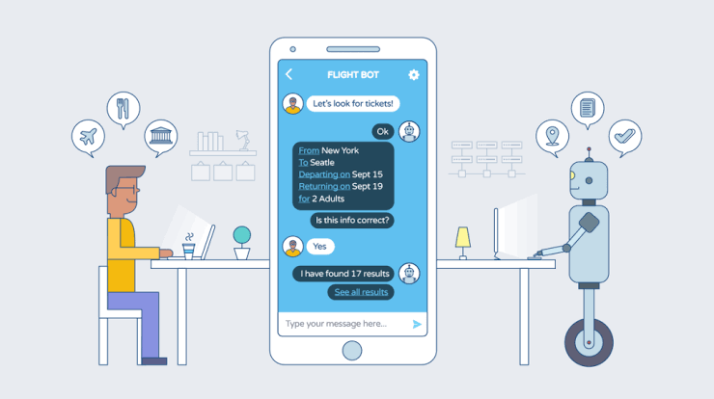](https://blog.markgrowth.com/how-chat-bots-can-help-you-increase-conversion-6561ba0b8ab0)

***What are Chatbots?***

A ***chatbot*** is a program or artificial intelligence which helps conversation via audio or in a textual method. Or it can be said that ***chatbot***  is a service, powered by rules and sometimes artificial intelligence, that interacts with chat interface. ***Chatbots***  are typically used in variety of cases i.e., shopping, helping services, financial services, productivity and many more.

The term ***chatbots***  was originally came from the word ***‘chatterBot’*** which was coined by Michael Mauldin in 1994. Today, most chatbots are either accessed via virtual assistants such as Google Assistant and Amazon Alexa, via messaging apps such as Facebook Messenger or WeChat, or via individual organizations' apps and websites.

Chatbots are typically used in dialog systems for various practical purposes including customer service or information acquisition. Some chatterbots use sophisticated natural language processing systems, but many simpler systems scan for keywords within the input, then pull a reply with the most matching keywords, or the most similar wording pattern, from a database.

***ChatBots for Financial Services***

[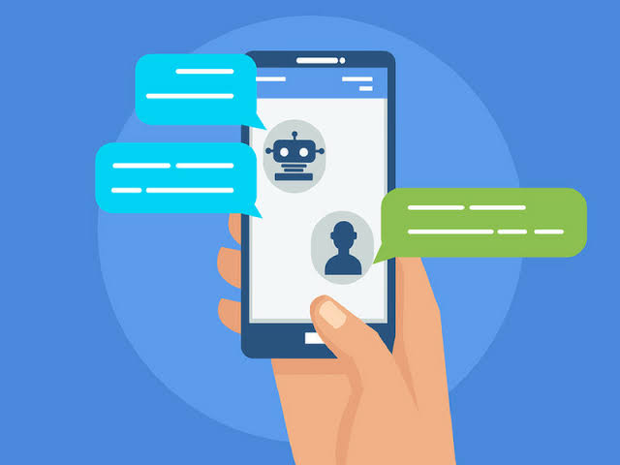](https://chatbotslife.com/how-to-increase-sales-with-chatbots-digital-marketing-e0e773aa3c0)

Financial services, start-ups are shaking up the industry by integrating chatbots to deliver immediate and insightful information to consumers. However, next to these start-ups, the use of chatbots in the financial services remains in an early stage. For many companies, it is not easy to create a truly valuable chatbot that both brings value to the customer and to the business.

**What is Financial Inclusion and how do chatbots relate to it?**

Financial inclusion is the idea of enabling or providing people, to access financial services such as personal banking and loans. Fintech helped in increasing the growth of financial inclusion. It has came to know that around and around 2 billion people hasn’t access to the financial inclusion.

By many surveys it has came to know that around ¾ of all people in the world has access to the cell service and has mobile phones but many amount them don’t even know or has access to the Financial Inclusion

***What services financial chatbots provides?***

[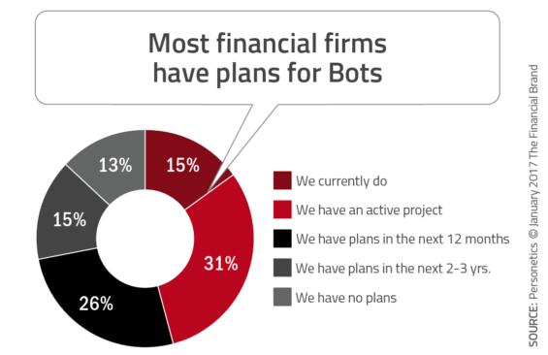](https://thefinancialbrand.com/63596/financial-banking-bots-chatbot-voice-ai/)

Some use of the ChatBots in field of Financial Services are money transfer, insurance, complaint handling,deposits and many more. Nowadays Chatbots are also used to help the people for many cases, like making them know how the particular thing work.

***What benefits do chatbots offer to clients?***

Chatbots are being made to ease the pain that the industries are facing today. The purpose of chat bots is to support and scale business teams in their relations with customers. It could live in any major chat applications like Facebook Messenger, Slack, Telegram, Text Messages, etc.

As Chatbots are becoming one of the main feature for futuristic society so it has some benefits too for clients which are, less time waste of the client, quicker solution to the issues, any time help and ease of accessibility is the most important benefit of it.

***what benefits chatbots offer to the bank?***

Introducing chatbots in the banking sector can bring a huge change in customer experience and keep up the pace with changing customer expectations.  
  
Chatbot has the potential to automate all the repetitive questions which are time-consuming and has a huge impact on the department’s performance. No matter the use-case, banks are now stepping forward to use chatbots to simplify the overall banking experience for the customers. Some of the benefits are uninterrupted customer support, feedback, personal banking services. One of the main benefit of Chatbots in banking is ease to serve them without any interruption.

***Downsides of Chatbots***

Chatbots are new technology,but they still do have some disadvantages. Chatbots are not that perfect, but they are still improving. Chatbots are not that understanding as they takes time to understand which may leads a client to frustration and makes a big downside of Chatbots. They also don’t have decision making tendency.

***Synopses on 10 Financial Inclusion Chatbots***

***1.* PBee** (PolicyBazaar)

Website:<https://www.policybazaar.com/>

Policybazaar is an insurance web aggregator, that let's you compare Insurance plans from different insurers. They setup a chatbot, called PBee, in year 2017-18. Policy bazaar has nearly 2 million dollar sale and it has experienced a monthly growth rate of over 30% and through feedback it has came to know that customers are very much satisfied by their service through Chatbots for faster replies.



**Launched**: 2017-18

**Platform**: Web ( and know being setup on apps too).

**Location**: India

**Market Focus**: Indian people

**Business Model**: For profit

**Size**: Large Company (500-1000 employees)

**Services**: Insurance aggregation

**Open Source**: No

**Additional Info**: $2M/month

**2. *Mr. Finance***

**Websites**:<http://www.onowmyanmar.org/mr-finance-bot/> <https://www.facebook.com/MrFinanceBot/>

Mr. Finance which is also called **Maung sa yin kaing** is a chatbot that aims to educate young Burmese ( Myanmar) entrepreneurs on how to manage their finances. The bot works through Facebook Messenger and offers microentrepreneurs short, digestible lessons on money management and financial well-being. Mr. Finance was designed to increase literacy around both business and personal finances, because for many of the bot's users, the two are often intertwined.



Launched: February 1st, 2017

Platform: Facebook Messenger

Location: Myanmar

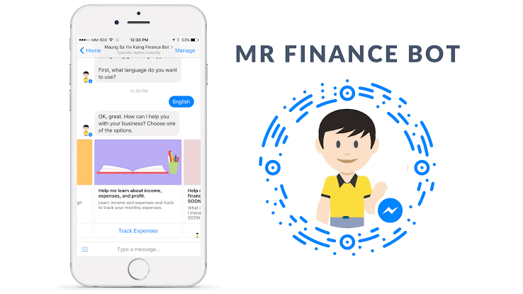**Language**(s): Burmese, English

**Market** **Focus**: Enterprising Youth in Myanmar

**Business** **Model**: NGO non-profit.

**Size**: more than 8000 users

**Services**: Financial advice

**Open** **Source**: No

**3**. **M-Pesa** Charges Bot

Website:<https://telegram.me/mpesafeesbot>

Ongair enables businesses all around the world to talk to their clients via Instant Messaging. We provide a robust, easy to use dashboard that lets you manage all your instant messaging accounts from a single platform.

It is specially designed for instant service for, firstly for African region but now it is spreading all around the continents like Asia, South America etc.

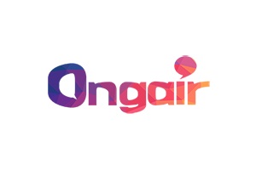

**Launched**: Sept 15, 2017

**Platform**: Telegram

**Location**: Kenya

**Language**(s): English, Swahili

**Market** **Focus**: M-Pesa (mobile money) users in Kenya

**Business** **Model**: Free app, made for publicity purposes

**Size**: Primary scale

**Services**: Mobile banking

**Open** **Source**?: No

4. **FinChatBot**

Website:<https://finchatbot.com/>

South African startup developing AI-powered chatbots for the banking and finance industry. The FinChatBot team is currently building a conversational agent (chatbot) powered by rules and Artificial Intelligence (AI) that interacts and communicates with customers on behalf of a business entity and through a chat interface.

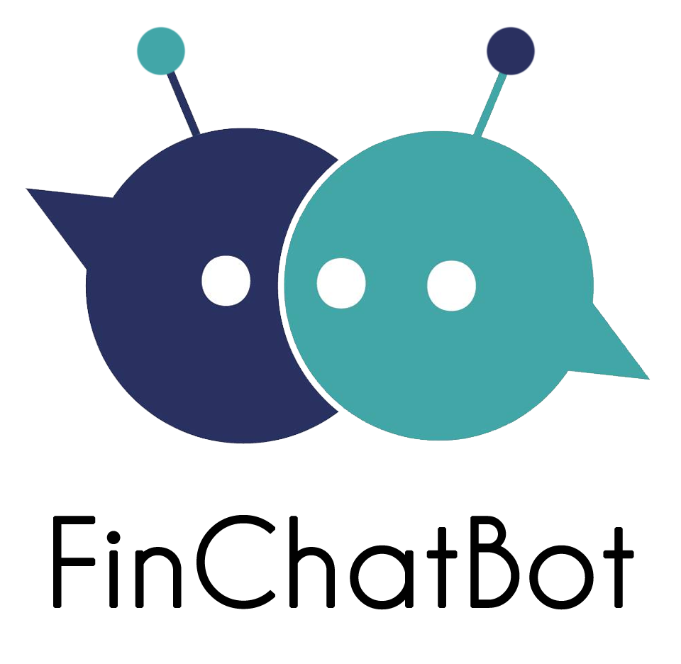

**Founded**: 2016

**Platform**: Messenger, WeChat, etc.

**Location**: Cape Town, South Africa

**Market** **Focus**: Banks

**Business** **Model**: B2B

**Size**: Startup

**Services**: Mobile banking

**Open** **Source**?: No

5. **Plum**

Website:<https://withplum.com/>

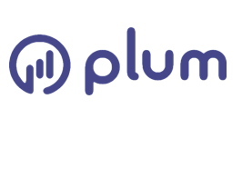

Plum, the fintech chatbot that helps you save, adds theme-based investing. ... This includes 'micro-savings' — rounding up any purchases you make — and other forms of regular saving, in which money is moved from your bank account to a segregated Plum savings account.

**Founded**: February 1st, 2016

**Platform**: Messenger

**Location**: London, England

**Language**(s): English

**Market** **Focus**: All

**Business** **Model**: For profit

**Size**: Startup

**Services**: Mobile saving

**Open** **Source**?: No

6. **Avaamo** Bot Platform

Website:<http://www.avaamo.com>

Avaamo provides an enterprise bot platform for banks and insurance agencies. The platform helps sales staff to plan customer visits. As well, the bot platform can send updates to customer relationship management software.

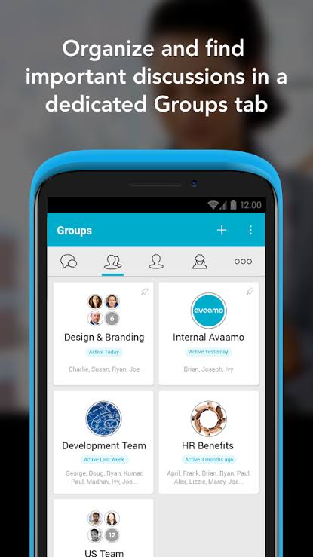

**Launched**: October 2nd, 2014

**Platform**: Any

**Location**: Los Altos, California, USA

**Size**: Medium

**Services**: Banking, Insurance,

**Open** **Source**?: No

7. **Habito** **Chatbot**

Website:<https://www.habito.com/>

The Habito chatbot dispenses mortgage advice to its users. Habito launches AI-powered chat bot to give mortgage advices. ... UK tech startup, Habito, has launched an artificially intelligent Digital Mortgage Adviser (DMA) that allows consumers to discuss their mortgage needs from any connected device throughout the day, without requiring a human broker.

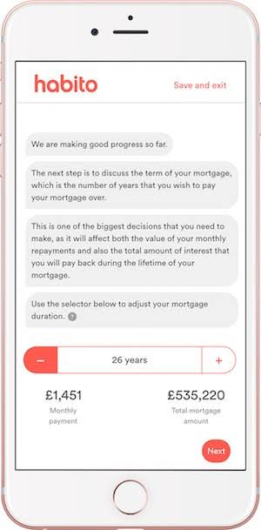

**Launched**: 2016

**Platform**: Web

**Location**: London, United Kingdom

**Team**: CEO: Daniel Hegarty

**Business** **Model**: For-profit

**Size**: Medium

**Services**: Mortgages

**Open** **Source**?: No

8. **Kasisto**

Website:<http://kasisto.com/>

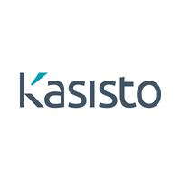

American startup creating a powerful AI platform, called KAI, for banks. Kasisto was founded in 2013 with the vision of enabling companies to engage and transact with their customers through intelligent conversations, anytime, anywhere. ... As an SRI International spin-off, Kasisto leverages decades of research and development in artificial intelligence.

Founded: 2013

Platform: Mobile Apps

Location: New York, USA

Language(s): English

Market Focus: Banks

Size: Secondary

Services: Mobile banking

Open Source?: No

9. **Ruuh**

<https://www.facebook.com/Ruuh/>

A chatbots developed by Microsoft India team. Specially for Indian market. You can talk in English as well Hindi. Ruuh is Microsoft's latest AI chatbot. Microsoft has unveiled a new AI chatbot, designed specifically for the youth population of India. The AI bot is named as Ruuh and is an aimed to provide entertainment only.



**Founded:** 2017

**Platform:** mobile apps

**Location:** India

**Language:** Hinglish

**Market focus:** India

**Size:**  primary

**Service:** social platform

**Open source:** no

**10. Prepathon**

https://www.prepathon.com/

Prepathon messages students the topic of the day, it answers questions and also sends across motivational messages. Aimed at helping students perform better at their exams, this chatbot is making their life easier.

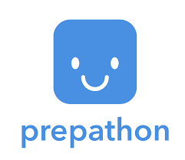

**Founded:** 2016 - 2017

**Platform:** mobile app

**Location:** India

**Language:** English

**Market focus:** India

**Service**: students problem solving

**Open Source:** yes

***Conclusion***

Decision reached by reasoning is that Chatbots are helpful for us in many ways and many field, but they need to be more advance to convert their cons to pros. They need to be improved and their complexity should be reduce to make it effective and helpful for futuristic society.